Entry Form
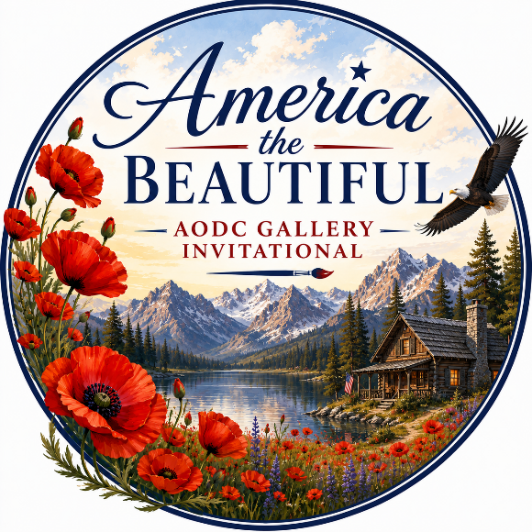
America the Beautiful
13th Invitational Art Show, August 1-30, 2026
AODC Gallery, Georgetown
Name (print) ____________________________________________________________________________________
Address________________________________________________________________________________________
City_________________________________State_______________________ZIP_____________________________
Phone____________________________________email__________________________________________________

Maximum of (2) entries
Title of Work Medium Size Price
1.
Inspiration for piece #1________________________________________________________________
2.
Inspiration for piece #2________________________________________________________________
Submit this form via email, aodcgallery@gmail.com. Hint…just snap a picture and attach to a message. Pay entry fee online at www.artonthedivide.com or mail to AODC Gallery P.O. Box 184, Georgetown, Ca. 95634. Include JPEG images in your email.

Signature____________________________________________Date______________________________________
I’ve read and accept the Exhibitor Information, Guidelines and Rules

