Art On the Divide Gallery will take the greatest possible care of all artwork, although we will not be responsible for loss or damage of any work. Artists are responsible for their own insurance.

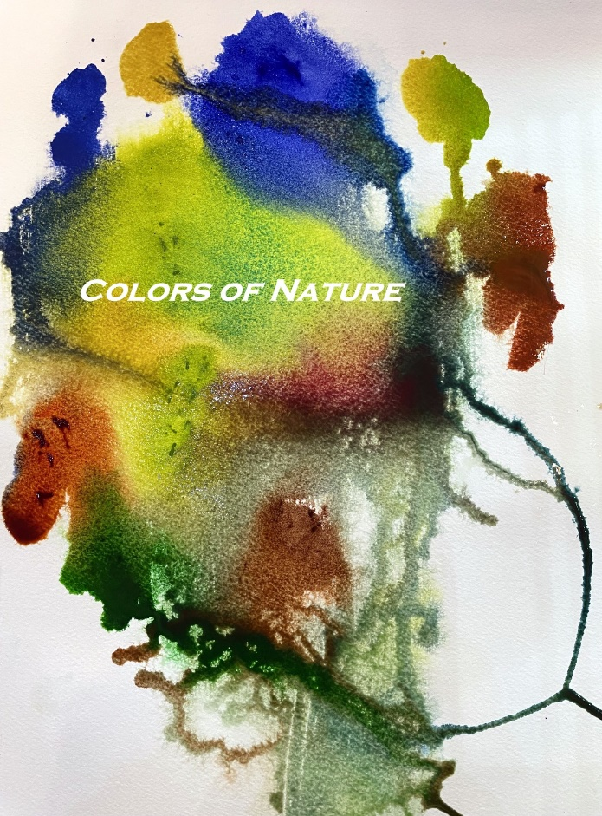
AODC Gallery, Georgetown Presents:
Colors of Nature
October 5-30, 2023
10th Annual Invitational Art Show
Application Deadline Sept. 10th
Early Bird special until Sept. 1st
Accepting Entries starting June 1st
Artists are invited to submit their work for inclusion in this juried show. We are looking for creative and innovative interpretations. We encourage both 3D and 2D entries for this show as we have added an award category for 3D. Submissions will be juried for acceptance into the show.

An opening reception to meet the artists will be held on Friday, October 6th, from 4-7 p.m. Save the Date

Exhibitor Information, Guidelines and Rules

Awards, 1st, 2nd and People’s Choice
A committee of artists from the gallery will jury in the pieces as well as determine 1st and 2nd place for both 3D and 2D submissions. A People’s Choice award will be recognized for both 3D and 2D by a ribbon at the end of the show

Entry Fee until September 1st is $25.00 for the 1st piece and an additional $10.00 for up to 3 pieces total

After September 1st and until September 10th, entry fee is $35.00 for 1st piece and an additional $10.00 for up to 3 pieces

Notification of pieces accepted or declined will be announced by email by Friday, September 22nd

Artwork drop off: Sunday, October 1st, 2023, 11 am to 4 pm
Artwork pick up: Tuesday, October 31st, 2023 11 am to 1pm
Location: AODC Gallery, 6295 Main Street, Georgetown, Ca.

The show will be publicized through local media, online, social media, and direct e-mail

Open to all artists. Artists to receive 80% of sales price on pieces sold through the show. AODC Gallery to receive 20%

Art must be original design within the last three years and for sale. Reproductions or giclees will not be accepted

2D artwork should be no larger than 24x36 inches. Gallery wrap is acceptable, but all pieces must be wired for hanging. Sawtooth hangers cannot be accepted

3D artwork is limited to 40 lbs and a 2x2 foot maximum footprint. All sculpture or 3-d pieces must be free-standing and stable

We encourage submission of payment via our website www.artonthedivide.com. Entry form and Jpeg images to support should be sent via AODCgallery@gmail.com. Hint…just snap a picture of the entry form and attach to your email. Alternately, payment and entries are accepted via USPS. Make checks payable to AODC Gallery. Send to P.O. Box 184, Georgetown, Ca. 95634

